**Usability Evaluation Plan**

Concept summary: The visualization seeks to evaluate relationships between what people around the world are eating and where they’re located, as well as some of the factors influencing their nutritional choices. The visualization also seeks to shed light on the production and consumption of the top ingredients for each showcased cuisine. The purpose is to explore meal choices and the healthiness of those choices around the world, and to inform and educate consumers as a whole.

Overall evaluation tasks:

1. Identify a region of interest, explore its popular meals.
2. Learn more about the components and production of those meals.
3. Make cross-regional comparisons.

Specific evaluation tasks:

1. Click anywhere to enter the visualization.
2. Choose a region on the map to explore.
3. Choose an ingredient.
4. Which countries have high production of the ingredient you chose?
5. Switch to a graph of production.
6. How many tons of the ingredient were produced in 2015?
7. Choose another ingredient to find information for.
8. Explore a different region.

Post-evaluation follow-up:

1. Evaluate and reflect on the entry screen depicting the theme of the visuation - the world on the plate.
2. Reflection the flow of your exploration. What did you like? What could be improved or done differently?
3. Did the visuals make sense for the types of information you were shown?
4. What did you like about the visualization?
5. What additional features or information would you have liked to see included?

**Evaluation Summary**

In total, the *Food For Thought* team has tested its design on 6 users who represented a fairly diverse educational spectrum. Specifically, the participants were comprised of 1 PhD, 2 masters, and 3 undergraduate students of male and female genders. The participants’ technical expertise and domain knowledge ranged from advanced to very basic. The first 3 tests were conducted in a classroom setting using paper prototypes, while the subsequent 3 tests took place on the University of Washington campus using an interactive Adobe XD digital prototype presented on a Mac laptop. The prototypes were black and white in both cases, but featured select color elements to simulate object selections. The usability testing team consisted of a moderator interacting with the participants and an observer responsible for note taking. All tests were conducted in-person.

The initial paper version of the prototype featured 4 interrelated page views: an introduction depicting a “world on a plate”, a map showing regional distribution of the most popular cuisines across the globe, a page showcasing each cuisine’s top ingredients and, finally, an ingredient-level nutrition and production breakdown presented on a spider chart, a map and a line graph. The navigation was envisioned through mouse clicking and hovering on an object of interest. “Go back” functionality was incorporated through a mini-map located at the top left corner.

User feedback, while generally positive, pointed to several areas needing attention and potential reevaluation. First, the forward navigation through the pages was highly intuitive and logical, but the go-back mechanism was slightly confusing due to the presence of multiple maps, occasionally on the same page. Second, some users had questions about the geographic breadth of the data: whether it represented the country- or region-level information and, if the latter, what a “region” actually meant. Third, a spider graph featuring nutrition information was deemed potentially overly complex and was advised to be replaced with a radar chart. Fourth, the top ingredient information depicted as a circle was considered “hard to read” due to text curvature and suggested to be arranged lineally. Fifth, production information led to a lot of questions as multiple categories were visualized on a dual axis over time. The participants wanted to know how production as a whole was tying back to the design’s themes of food and health, as well as how to access its significance through the use of color and texture or other visual aids. Other production questions related to the interpretation of the white space on the map and whether it signified low production areas, a lack of production altogether, or just a lack of information for that area. Additionally, there were minor inconsistencies with the dual axis scale, which were brought to the team’s attention. Finally, it was pointed out that production location did not necessarily convey any information about the popularity of an ingredient around the globe and whether production location was something the design could help users explore. The last area of improvement concerned introducing cross-regional comparisons for the metrics to allow for more interactivity and insight.

The strength of the design related to its clever use of food themes, metaphorically leaving the participants hungry for more information. Everyone loved the “world on a plate” interface, with the comments ranging from “it is really cute” to “you have done a nice job here”. The navigation, aside from the go-back functionality, was also considered a success with not a single participant struggling to find their way around. Similarly, the concept to concept flow of the visualizations generated a lot of positive feedback, with one participant in particular raving about its “very intuitive” nature. A map depicting the top regional cuisines was considered “a good way to start reflecting on the world’s food habits” by taking users on a literal and metaphorical journey across the globe.

After aggregating and discussing the feedback, the team incorporated it into the iterated design. The new prototype resolved the go-back navigation issue by adding a “Back to Map” title to the mini-map at the top left corner. Additionally, the production segment was converted into a bar chart visualization getting rid of the second map and eliminating the resulting navigational confusion. Secondly, the most popular regional ingredients became a list instead of a pie chart. Third, the spider chart depicting ingredient nutrition was replaced with a radar chart that contained a color-coded legend to differentiate between the top ingredients. Fourth, production visualization was broken down into 2 separate components, production and utilization. Instead of using the time series and dual axis, the chart focused on presenting the latest information on a single axis to make the interpretation as clear as possible. Fifth, a cross-regional comparison for all 3 statistics – ingredients, production, and nutrition – was introduced as a separate visualization. Further, a drop-down list functionality was added to the comparison page that allows users to change a region on the fly. To make the go-back to the statistics screen navigation more seamless, a label “Back to [Region A] Statistics” was incorporated into the comparison page. Finally, to alert users that comparison was possible in the first place, a label “Click to Compare” was included on the main statistics page.

The second series of usability studies had the participants play with a digital prototype themselves following the *Think Aloud* protocol. Overall, everyone loved the “cool concept” and felt that the flow was “great”; however, there were some technical and thematic suggestions to make the experience more engaging and easily understood. For one, the most popular ingredient list was advised to be numbered to make the ranking aspect clear. Secondly, the participants suggested changing the word “ingredient” to a “food item”. Third, it was pointed out that the top ingredient list included more line items than the corresponding production and nutrition charts. Fourth, less technical participants suggested replacing a radar chart with a pie chart for greater clarity. Interestingly, a more technical user proposed keeping the radar chart but showing nutrition for only 1 ingredient at a time and switching ingredients by clicking on the side legend. Fifth, the production and utilization chart caused confusion, with the participants requesting for “utilization” and “production” to be clearly defined. Sixth, some participants felts that the health theme could be conveyed with greater clarity, for example by introducing the healthiness comparison across regions. Somewhat similarly, it was suggested to add popular recipes and storytelling elements to the presentation in one form or another to create a richer overall experience. The need for showing utilization and production data was to be communicated better, as some felt that that particular visualization did not fully tie into the theme of food and health. Finally, there was a sentiment of the visualization being fairly quick to explore, leaving the participants hungry for more information. Recipe and write-up addition would help to provide more context and depth to the experience.

On the plus side, both the concept and the visuals were considered engaging and user friendly. The expectation of clicking on a region, learning about a popular meal, and then evaluating its components was fully met. The interactivity of the design (e.g. drop-down menus, clicking on hot-spots to switch to a different page, etc.) were universally praised. A desire to test a more fleshed out colored version was voiced. The process sparked the participants’ curiosity and inspired them to learn more.

**Appendix A: Design Iteration I (Paper Prototype)**

Entry Page:

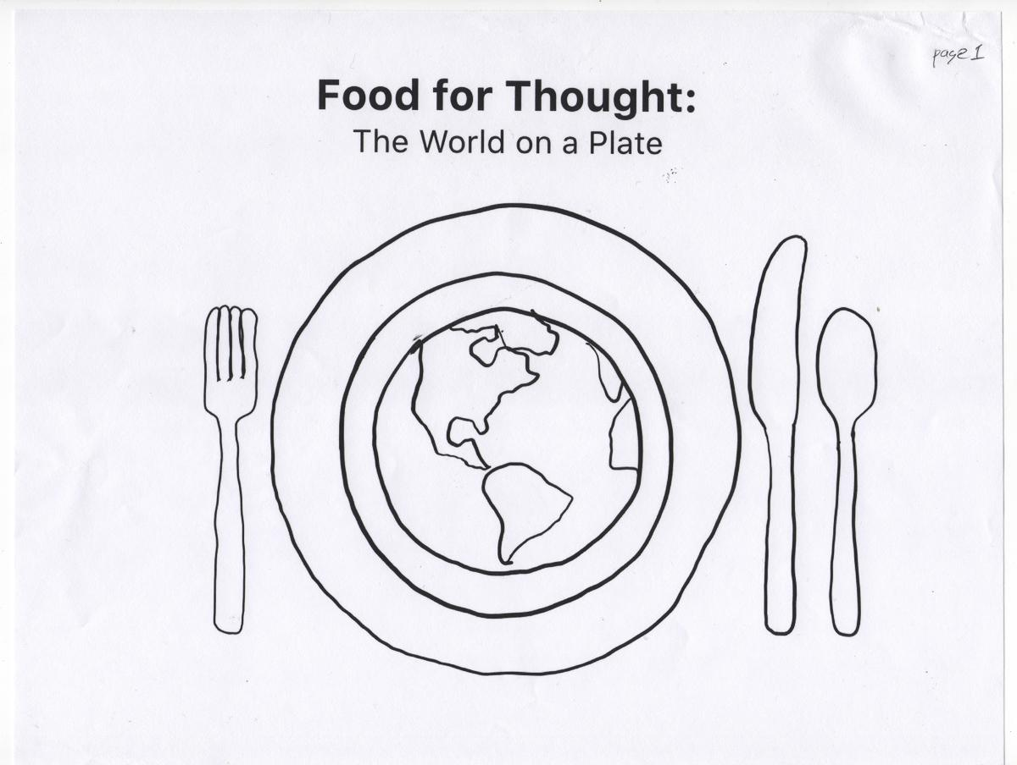

Choosing Region:

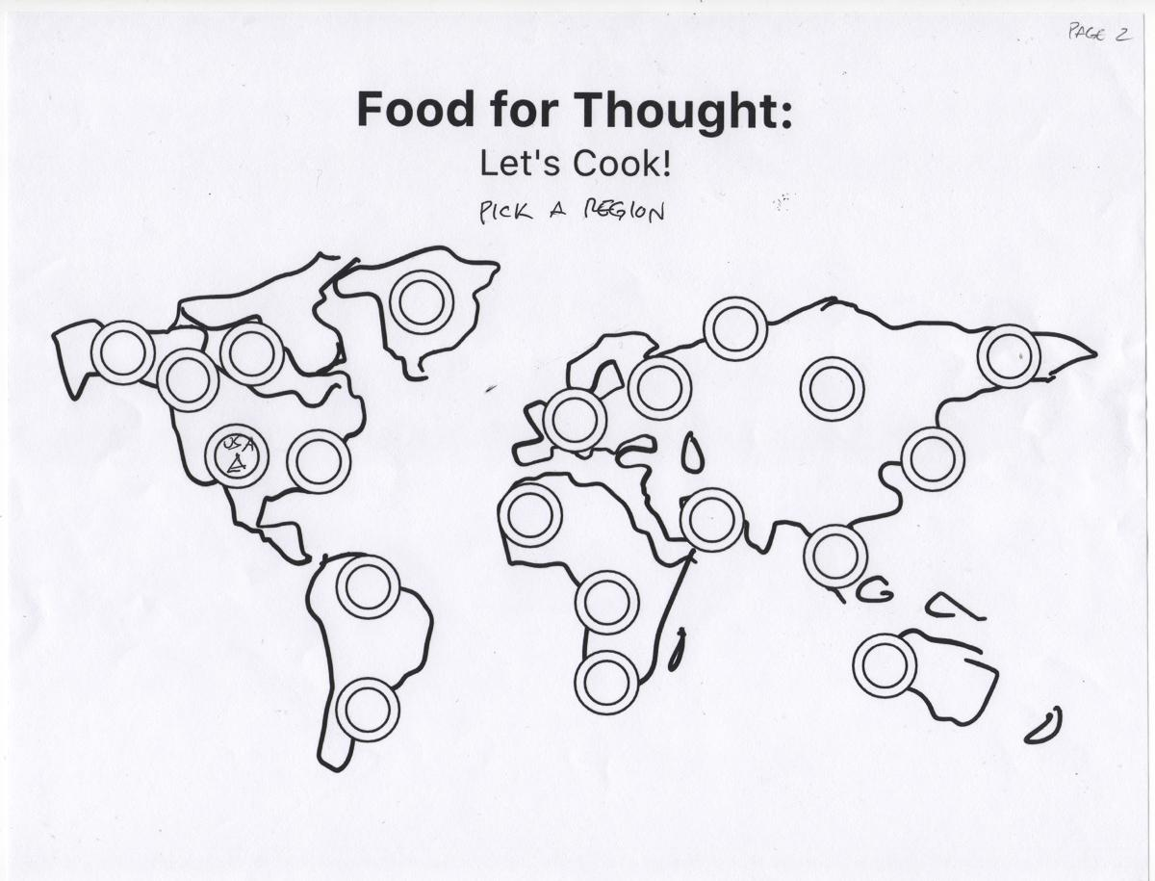

Ingredients, Nutrition, and Graph View:

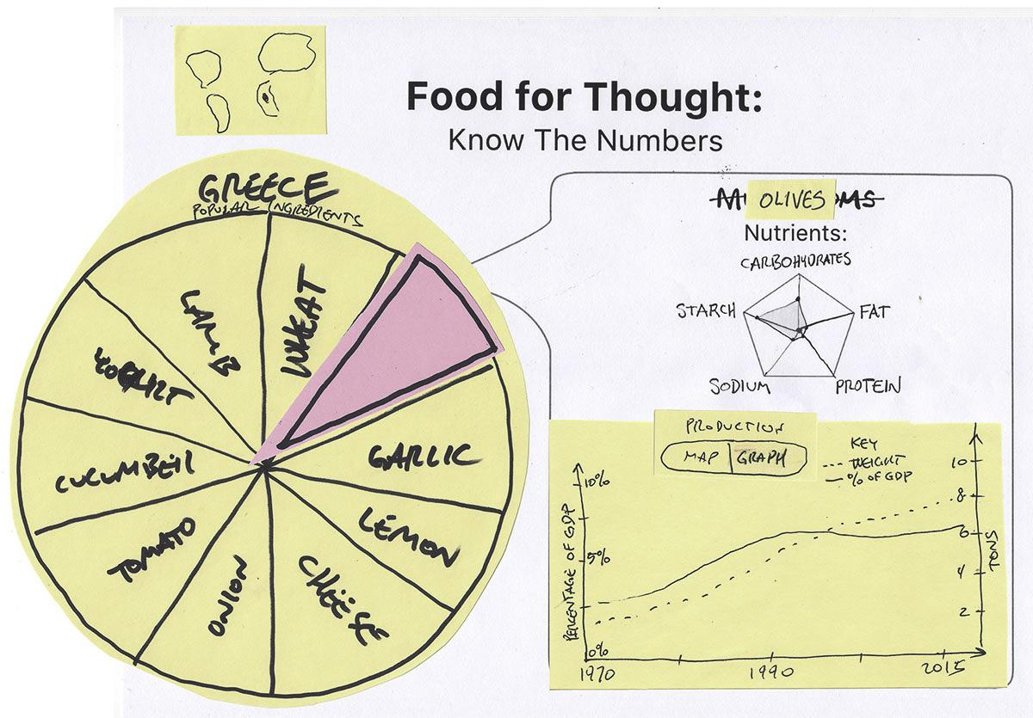

Ingredients, Nutrition, and Map View:

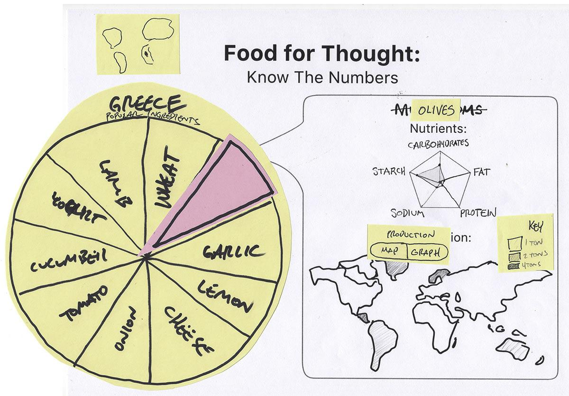

**Appendix B: Design Iteration II (Digital Prototype)**

Home Page:

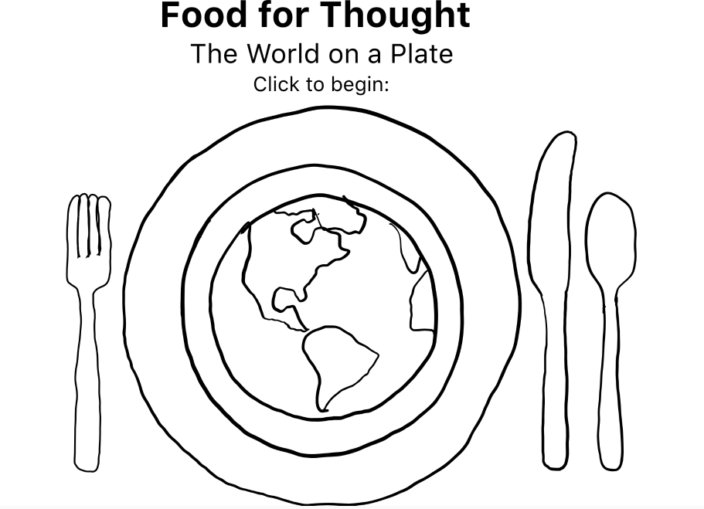

World map for different cuisine types:

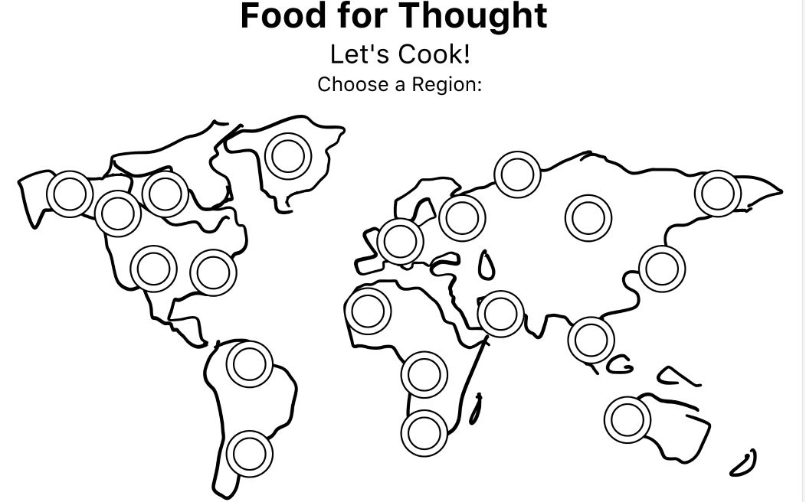

Cuisine info breakdown:

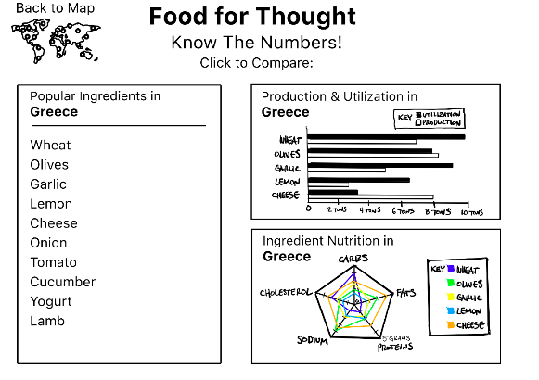

Comparison pages across cuisine types:

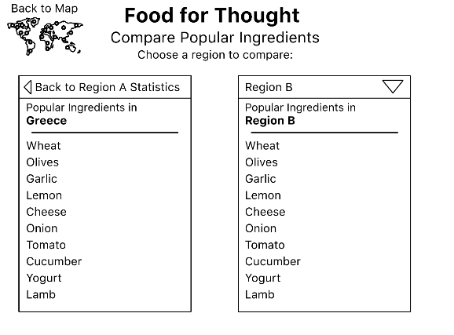

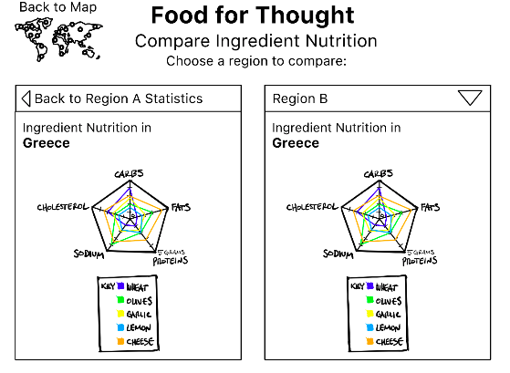

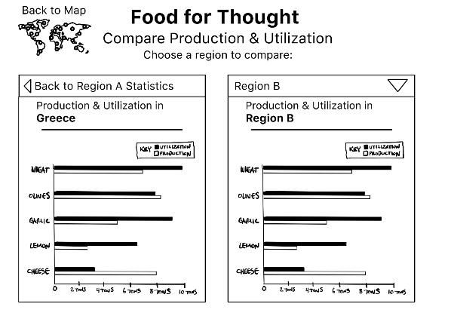

Region B dropdown selection:

